**Module 5**

**About Assignment**

Q1) Create row-level security for the Central region (Submit the screenshots of the Row level security after publishing into power BI Service).

Q2) Schedule a refresh at 9:00 am IST daily frequency () Submit the screenshots of the scheduled refresh after publishing into Power BI Service).

Q1) Screenshots are as below

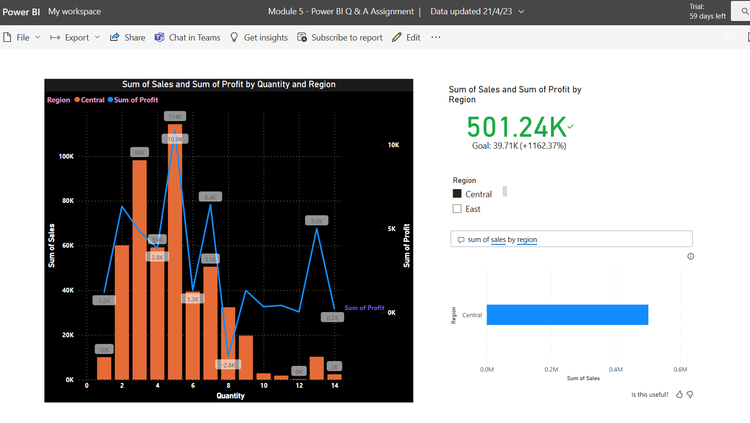

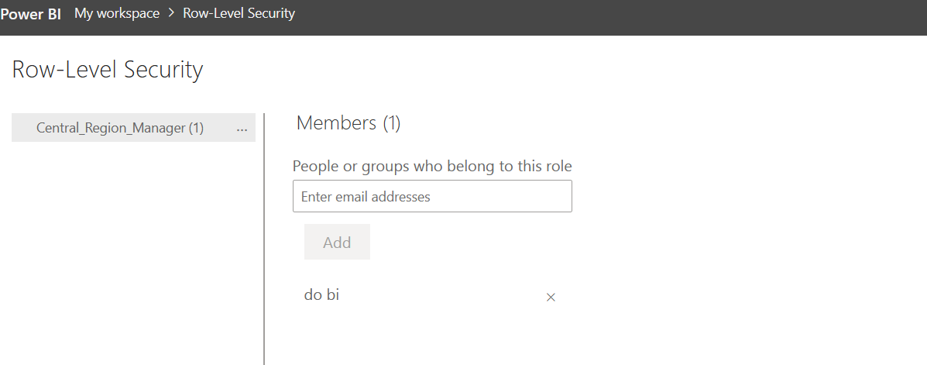

Q2) Screenshots are as below .

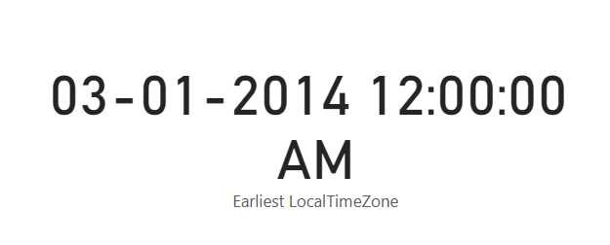

It shows 12 am IST because the time given in the dataset reflects as 12 am.

Time given in dataset is not proper.